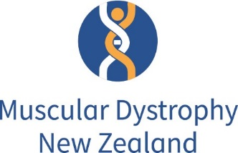

Media Release
Issued by Muscular Dystrophy New Zealand (MDANZ)
May 29, 2020

Pharmac recommendation will change children’s lives

The membership organisation representing New Zealanders living with rare neuromuscular conditions, Muscular Dystrophy New Zealand (MDANZ), is very pleased and relieved to learn that children with the progressive muscle-wasting disease, spinal muscular atrophy (SMA), should soon have access to the life-changing treatment, nusinersen.
MDANZ’s programme and service advisor, Miriam Rodrigues, says the recommendation by Pharmac’s Pharmacology and Therapeutics Advisory Committee (PTAC) to give nusinersen a high priority for funding for all children with SMA (as long as signs and symptoms of the disease were present before they were three years of age) is excellent news.
She says the recommendation means that 30 children in New Zealand will be able to receive this life-changing treatment.
“The urgency to fund this drug is crucial in a way most New Zealanders would probably find hard to understand.
“Children with SMA are literally in a race against time and the progressive death of their motor neurons which affects their mobility and breathing and can result in early death.”
She says there are different types of SMA from type 0, being the most severe and obvious at, or even before, birth to type 4, which also known as adult-onset SMA.
Pharmac's recommendation for high priority funding is for infants and children with types 1, 2, and 3a as well as pre-symptomatic infants with a particular type of gene combination that means they would likely go on to develop SMA type 1 or 2 or 3.

Ms Rodrigues says that MDANZ now expects Pharmac to uphold the committee’s recommendation as soon as possible so these children can have immediate access to a treatment that will change their lives and the lives of their families and whanau.
For further comment or an introduction to a member of MDANZ whose family has lived experience of SMA please contact Miriam Rodrigues on 0274 688 044 or miriam@mda.org.nz
For more information on the Muscular Dystrophy Association of New Zealand see www.mda.org.nz
The Pharmacology and Therapeutics Advisory Committee Meeting records are available on https://www.pharmac.govt.nz/assets/ptac-minutes-2019-02.pdf

