MDANZ Membership
Application Form

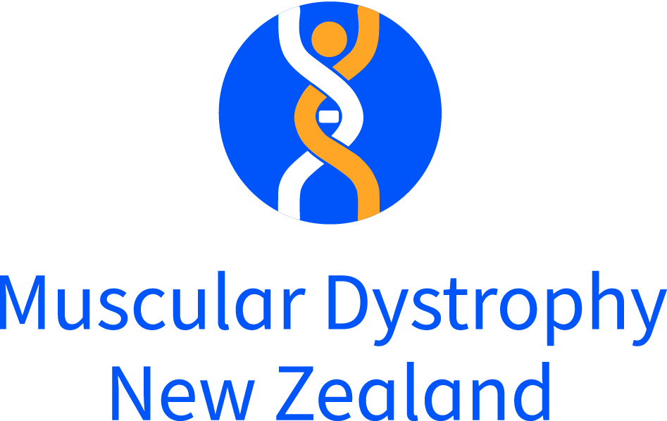

Personal Details (please complete one form per member)
Title: Mr / Mrs / Ms / Miss

Gender: M / F / Non-binary / Do not wish to disclose

Date of Birth: ______/________/___________ Ethnicity: ___________________________________________

Name: __________________________________________________________________________________________

Physical Address: __________________________ __________________________ _______________________
__________________________________________________________________________________________________
Postal Address (if different): _________________________________ _________________________________
_________________________________________________________________________ ________________
Preferred Contact Number: ___________________________Other Number: ______________________
Email: ______________________________________________________________

Emergency Contact Name: __________________ __ Number: ________________________

Neuromuscular Condition Details
(Please complete this section if you have a neuromuscular condition)

Condition: ___________________________________________ or UNKNOWN
NHI Number: ________________________________________
Date of Diagnosis: ______ _/____ __/___________ or NOT FORMALLY DIAGNOSED
Current Neurologist: ___________________________________________________________________________
Current GP: ___________________________________________GP Phone: _____________ _________________
GP Address: _________________________________________________________________ ____________ _____
Yes, please send my GP information about my condition/neuromuscular condition
Note: If you are the parent/guardian/relative of an existing or new member with a condition, please list their name and condition so we can link your membership accounts:

Name: ______________________________________ Condition: _________________________________________

How did you hear about MDANZ?
Friend GP Neurologist Paediatrician Genetics Department
Website Family Other (Please specify) _______________________________________________________
Disclosure: The information I have provided is accurate. I understand that this and other information provided to the Muscular Dystrophy Association of NZ will be kept confidentially in accordance with the Privacy Act 2020 and the Health and Information Privacy Code 2020. I understand my information may be accessed by people in the services of MDANZ which includes, staff, council / committee members & volunteers.

Name: ____________________ ______

Signature: ______________ Date: __ _____

OFFICE USE ONLY

OFFICE USE ONLY

Membership Types
MDANZ will assign you a membership type and membership number when processing your membership application form. Your membership type & number will be noted on your welcome letter.
Child /Tamariki Members shall consist of anyone under the age of sixteen living with a Condition
Young/Rangatahi Members shall consist of anyone between the ages of sixteen and twenty-five years who is living with, or is a carrier of, a Condition
Individual/Takitahi Members shall consist of anyone over the age of twenty-five years who is living with, or is a carrier of, a Condition
Family/Whānau Members shall be one of the following:
A parent or guardian of a Child/Tamariki, Young/Rangatahi or Individual/Takitahi Member
An immediate sibling of a Child/Tamariki, Young/Rangatahi or Individual/Takitahi Member
A husband/wife/spouse/partner of a Young/Rangatahi or Individual/Takitahi Member.
Life Member/Ringa Tōhau Nui is a Member of a Branch who is honoured for meritorious services to the Association
Friend of the Association/Hoa Tāpui shall consist of any person, including any individual, health professional, incorporated or unincorporated body, who wishes to be associated with and receive information from a Branch or the Association.

o Membership #: _______________________________________
o Membership Type: ___________________________________
o Branch/NO sent details
o Support Network signed o Health Info Release Form signed
o Vega updated
o Membership pack sent o GP pack sent

Authorisation to Disclose Information
Under New Zealand law*, information about your health should always be treated carefully by health and community agencies. Therefore, we need your permission to collect or disclose information about you (or your child/family member).

The information you share with the Muscular Dystrophy Association of New Zealand (MDANZ) is voluntary. Any information collected will be stored in an electronic system which is password protected or in a locked filing cabinet. Your information will only be accessed by people in the services of MDANZ who are MDANZ staff, committee / council members and volunteers who have all signed confidentiality agreements.

By signing this form, you agree to us sharing relevant information about you (or your child/family member) with health professionals, community or government agencies, education providers or disability support agencies. This information will only relate to the agreed goals or outcomes that we have discussed with you.

You have the right to ask for copies of information we hold about you and to ask for any inaccurate information to be corrected.

I ______________________________________________agree to information about me /my child/ my family member being collected and disclosed by MDANZ.

I understand that disclosure of information will only be relevant to my healthcare and wellbeing.
I understand that information will be stored in accordance with the Health Information Privacy Code 2020. I understand I can request copies of information from MDANZ and ask for inaccurate information to be corrected.

Signed: ____________________________ Dated: ___________________________

If applicable: I ______________________________________also agree to information about me/my child being shared with the following members of my family.

Name: _______________________________ Relationship: ______________________________

*Privacy Act 2020 and Health Information Privacy Code 2020.

